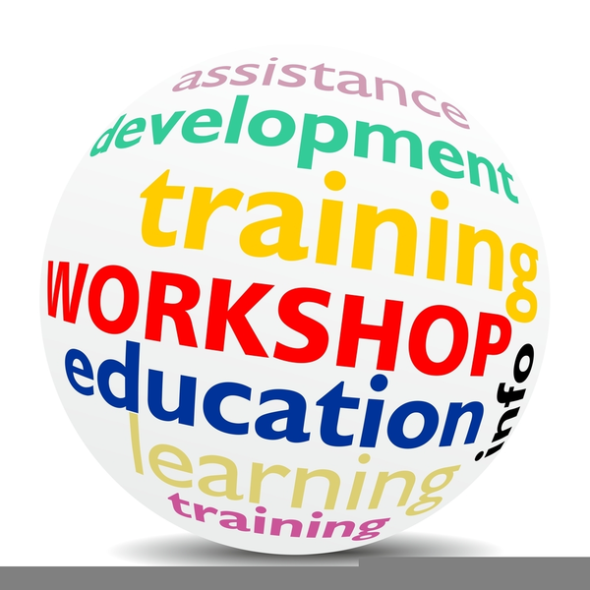  Aug 22 & 23  2019 TRANM Workshop  UNM Continuing Education Conference Center  Conference Room C  1634 University Blvd. NE  Albuquerque, NM 87131  The TRANM Board and Education Committee would like to invite you to our 2019 TRANM Workshop.  We are very excited about this year’s lineup of speakers which include national speaker Karen Mace, CTR, RHIT as well as a great variety of local speakers including Jan Esparza, MA, RD, LD, CNSC; Jean McDougall, PhD, MPH; Angela Meisner, MPH; and Ginger Williams, CTR. | SPEAKERS  Karen Mace  Compliance &  Quality Mgr  HIMAGINE  Jan Esparza  Advanced Practice Dietician  Presbyterian  Jean McDougall  Assistant Professor  Epidemiology, Biostatistics and Preventive Medicine  UNM  Angela Meisner  Epidemiologist  NMTR  Ginger Williams  Sr. Program Mgr  NMTR  Registration  Information  Coming Soon!

