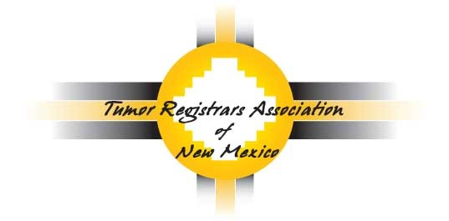

2019 TRANM Annual Conference
Day 1: Thursday, August 22, 2019
7:30 am to 4:30 pm
Day 2: Friday, August 23, 2018
7:30 am to 12:30 pm

UNM Continuing Education Conference Center
1634 University Blvd NE
Albuquerque, NM 87131

Conference Registration
Name: _____________________________________________________ Title: ______________________
Facility: _________________________________________________________________________________
Address: ____________________________________________________
State: ___________________________________ Zip: ______________
Telephone: ______________________________ Email: ________________________________________
Postmark registration and fees by August 8, 2019 for early registration
Member Registration: (early) $40.00 (after August 8) $50.00
Non-member Registration: $65.00
*Registration includes 2 breakfasts, 1 lunch and snacks
Please return the registration form with your check made out to:
Tumor Registrars Association of New Mexico

Mail Registration & Check to: Deanna Rhodes
1520 University Blvd.
Apt. 160
Albuquerque, NM 87102

For questions, please contact: tranm.president@gmail.com, tranm.vicepresident@gmail.com or tranm.treasurer@gmail.com

