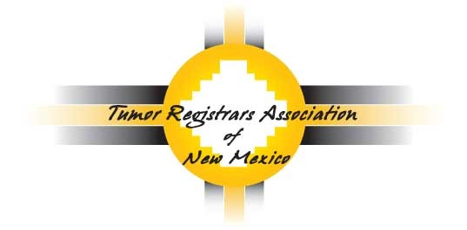

2021 TRANM Annual Conference

Day 1: Thursday, September 9, 2021
8:00 am to 4:00 pm
Day 2: Friday, September 10, 2021
8:00 am to 12:00 pm

Conference Registration
Name: _______________________________________________ Title: ______________________
Facility: __________________________________________________________________________
Address: ____________________________________________________
State: ___________________________________ Zip: ______________
Telephone: ______________________________
Email: ________________________________________

Member Registration: FREE to Members (Please complete registration form & return)

Non-member Registration: Become a member ($35.00) & attend the conference for FREE OR pay $50.00 to attend the conference ONLY.
(Please Email jsullo@salud.unm.edu for the Membership form)

Please return registration form to: jsullo@salud.unm.edu
OR
Jennifer L. Sullo
5023 Calle de Carino Street NE
Albuquerque, NM 8711

For questions, please contact:
- Elizabeth Ramirez-Valdez (President) at: ERamirezValdez@salud.unm.edu
- Tanya Dalley (Vice-President) at: TDalley@salud.unm.edu
- Jennifer Sullo (Treasurer) at: Jsullo@salud.unm.edu

